Abaad center
2011
First step Center for master scholarships and research

Fedaa ElDerdesawe
Elreamal-Khaled bin Alwaleed street

First step Master scholarships for Gaza graduates

Executive summary

First step to encourage development in Gaza through education of young people for whom such opportunities would not otherwise be available where First step main aim is to contribute to the social, economic and political development of Palestine through scholarships for Palestinians to study at European Universities so it will be awarding postgraduate scholarships to new Masters students at European universities on an annual basis. And in each year will give more than 4 awards of 40000$ will be made to students starting their programs in September 2011.
Successful applicants will also receive a further Full tuition fees plus living costs to be paid in October. Scholarship is for the duration of the course.

Center Hierarchy
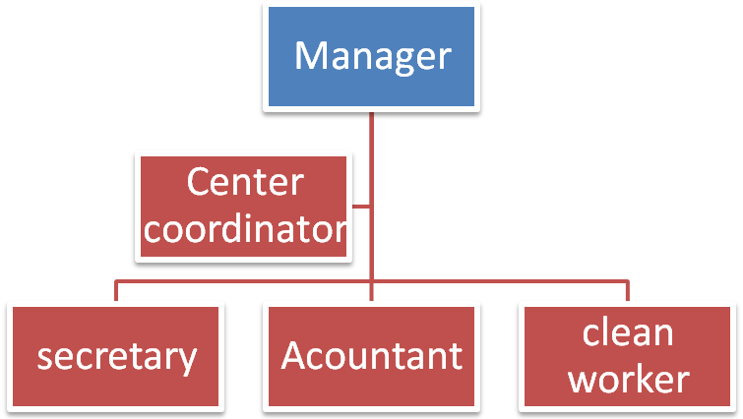

Goal
To make academy or center which concerns with scientific research and encourage postgraduates studies.

Objectives
The scholarship fund aims to reward the most academically gifted students from Gaza graduates .these scholarships are to aid students in financial hardship due to the fact that they are domiciled in a country that is in crisis as a result of the political situation, war, natural disaster etc

Methods
First step center will make relationship between local and European universities to ensure the admission of students in those universities and provide the necessary facilities to them like Visa and tuition fees. Also it will be the focal point between students and donors so the center will accept the applications of students and then there will be sorted to choose the best candidates who will get the scholarships.
The conditions for student who wants to be eligible for our scholarships:
- Have a Palestinian nationality
- Be between 24 to 40 years of Age.
- Have a good bachelor degree from the Palestinian universities.
- Provide evidence of your proficiency in English (IELTS or TOEFL certificates)
- Have at least two years' work experience.
Financial plan
Fixed costs
1-Furniture
Equipments | unit cost($) | Number of units | Total cost($)
Book case | 300 | 2 | 600
desks | 250 | 3 | 750
helping desks | 150 | 2 | 300
Lab top | 800 | 1 | 800
computers | 400 | 2 | 800
Normal chairs | 30 | 8 | 240
printer | 150 | 2 | 300
Manager chairs | 250 | 2 | 500
Telephones | 30 | 2 | 60
Total cost |  |  | 4350

Running costs
Expenses per month | Cost $
Renting cost | 200
stationary and petty expenses | 150
hospitality | 30
First aid supplies | 9
cleaning supplies | 5
Electricity | 100
water | 10
fuel | 45
Telephone | 150
Internet | 50
Total operating cost | 749

Staff wages:
Staff | unit cost($)  per month | Number  of unit | Total
Manager | 600 | 1 | 600
Secretary | 300 | 1 | 300
Center coordinator | 400 | 1 | 400
Accountant | 300 | 1 | 300
Clean worker | 200 | 1 | 200
Total wages per month | 1800 |  | 1800

Needed costs for four students scholarships per year.
Scholarships costs | Average Cost /year | # of scholarships | Total cost
Tuition costs | 11000 | 4 | 44000
Travel costs | 2000 | 4 | 8000
Living and accommodation costs | 6000 | 4 | 24000
Needed costs for scholarships |  |  | $ 76,000

Total Expenses for the project
Resources | cost /Year
Furniture | $ 4,350
Wages | $ 21,600
Running costs | $ 8,988
Scholarships cost | $ 76,000
Total Expenses | $ 110,938

